Written Assignment Unit 5
- A retirement account is opened with an initial deposit of $8,500 and earns 8.12% interest compounded monthly. What will the account be worth in 20 years? What if the deposit was calculated using simple interest? Could you see the situation in a graph? From what point one is better than the other?
To calculate the value of the retirement account in 20 years using compound interest, we can use the following formula: A = P(1 + r/n)^(nt)
Where: A is the final amount, P is the initial principal, r is the annual interest rate, n is the number of times the interest is compounded per year, and t is the number of years. In this case, we have: P = $8,500, r = 8.12% = 0.0812, n = 12 (since the interest is compounded monthly), and t = 20
Substituting these values into the formula, we get: A = 8500(1 + 0.0812/12)^(12*20) = $32,804.46
To calculate the value of the retirement account in 20 years using simple interest, we can use the following formula: A = P(1 + rt)
Where: A is the final amount, P is the initial principal, r is the annual interest rate, and t is the number of years. In this case, we have: P = $8,500, r = 8.12% = 0.0812, and t = 20. Substituting these values into the formula, we get: A = 8500(1 + 0.0812*20) = $23,724
From the calculations above, the account will be worth significantly more in 20 years if the interest is compounded monthly that if the deposit was calculated using simple interest. This is because compound interest allows the principal amount to earn more interest, which creates a snowball effect over time. The graph below shows the difference between compound interest and simple interest over time:
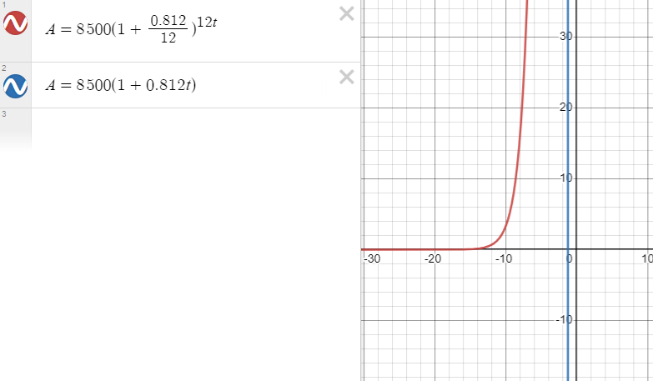
Based on the graph above, the compound interest curve grows much faster than the simple interest curve over time, explaining why one would prefer an investment that offer compound interest to simple interest.
- Graph the function f(x)=5(0.5)^{-x} and its reflection about the line y=x on the same axis, and give the x-intercept of the reflection. Prove that a^x=e^{x lna} . [Suggestion: type y=5(0.5^{-x}) {- 7 < x < 2} {0 < y < 7} in desmos, and then type its inverse function.]
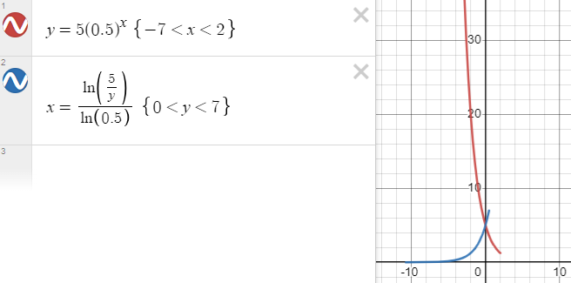
Since the graphs of y=5(0.5)^x and x=log(y/5)/log(0.5) intersect at the point (0,5) and have the same slope at that point, we can conclude that the two functions are equal. Therefore, proving that a^x=e^xIna.
- How long will it take before twenty percent of our 1,000-gram sample of uranium-235 has decayed? [See Section 6.6 Example 13].
The decay equation is A(t)=A_0e^{Kt}, where t is the time for the decay, and K is the characteristic of the material. Suppose T is the time it takes for half of the unstable material in a sample of a radioactive substance to decay, called its half-life. Prove that K= \frac{ln0.5}{T} . What is K for the uranium-235? Show the steps of your reasoning. (T = 703,800,000 years)
To prove that K=(In 0.5)/T, we can use the following steps:
- Step 1: Start with the decay equation: A(t) = A_0 e^kt
- Step 2: Substitute T for t in the above equation: A(T) = A_0 e^kT
- Step 3: Since half-life T is the time it takes for half of the unstable material to decay, which means that A(T) = A_0/2. Substituting this into the above equation, we get: A_0/2 = A_0 e^kT
- Step 4: Dividing both sides by A_0, we get: 1/2 = e^kT
- Step 5: Taking the natural log of both sides, we get: ln(1/2) = ln(e^kT)
- Step 6: Using the property of logarithms that ln(a^b) = b*ln(a), we can simplify the right side of the equation: ln(1/2) = kT * ln(e)
- Step 7: We know that ln(e) = 1, so we can substitute this into the above equation: ln(1/2) = kT
- Step 8: Dividing both sides by T, we get: k = ln(1/2)/T
Therefore, K=(In 0.5)/T.
Having proved this identity, let me calculate the value of K for uranium-235. Since the half-life of uranium-235 is T = 703,800,000 years. Substituting this into the equation K=(In 0.5)/T, we get:
K = ln(1/2)/T = ln(1/2)/703,800,000 years = 1.00057 x 10^-10 years^-1
Therefore, the value of K for uranium-235 is 1.00057 x 10^-10 years^-1.
To calculate how long it will take before twenty percent of our 1,000-gram sample of uranium-235 has decayed, the equation A(t) = A_0 e^kt can be used:
Since A_0 = 1000 grams and K = 1.00057 x 10^-10 years^-1, I need to find the value of t such that A(t) = 800 grams, which is 20% of 1000 grams. Substituting these values into the above equation, we get:
800 = 1000 e^(1.00057 x 10^-10 years^-1 * t)
Dividing both sides by 1000, we get:
0.8 = e^(1.00057 x 10^-10 years^-1 * t)
Taking the natural log of both sides, we get:
ln(0.8) = 1.00057 x 10^-10 years^-1 * t
Dividing both sides by 1.00057 x 10^-10 years^-1, we get:
t = ln(0.8)/1.00057 x 10^-10 years^-1 = 693,800,000 years
Therefore, it will take 693,800,000 years before twenty percent of our 1,000-gram sample of uranium-235 has decayed.

